**Run 48 – 5.3km run**

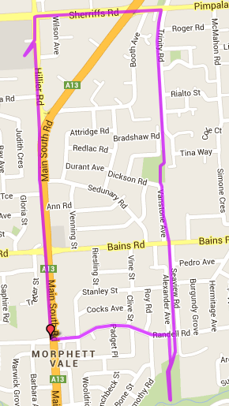

**Directions**

1. From the park run up the track to Bains Road and continue to Pimpala Primary School
2. Continue to Pimpala Road and turn left, past Hungry Jacks and across traffic lights
3. At top of the hill turn into Hillier Road and cross road near Southgate shopping centre
4. Follow Hillier road down the hill and continue on Main South Road. At O’Sullivan’s Beach/Bains Road traffic lights cross intersection to Catholic Church
5. Continue down Main South Road until Inner Wear (Old Church) on left
6. Continue until Traffic lights at Randell St and turn left
7. Follow Randell St till the bridge crossing the bike track then turn right and follow back to the park

**Start & Finish**

**Directions**

1. ##

**3**

**Run 48 – 10.3km Run**

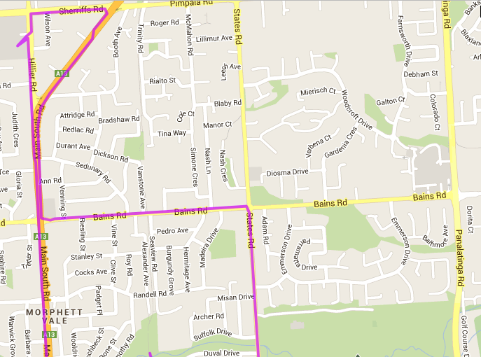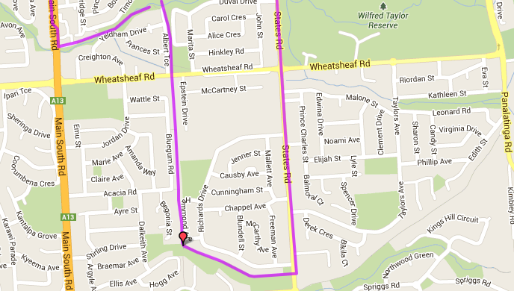

**Directions**

1. From the park take track to Wheatsheaf Road and continue to Southern Districts Working Men's Club (on left)
2. Continue till wooden bridge and follow track to the left until you reach States Road
3. Cross States Road and turn left
4. Follow States Road till shops just before Wheatsheaf Road roundabout
5. Continue along States Road until Bains Road and turn left – follow till Main South Road traffic lights
6. Cross MS road and turn right, following the road towards McDonalds (Sheriffs Rd)
7. Turn left into Sheriffs Rd to top of hill and Southgate shopping centre
8. Follow Hillier road down the hill, crossing Main South Road until Inner Wear (Old Church) on left
9. Continue until Traffic lights at Randell St
10. Continue down MS Road till the ‘On the Run’ petrol station
11. Turn left after the Emu hotel and follow the track back to the park

**Start & Finish**

**Run 48 – 20.3km Run**

**Directions – First 10km**

1. Follow track to Wheatsheaf road and turn right, crossing MS road and continuing until Brodie/Kenneth Road (Ambulance Station)
2. At next major road (Elizabeth Road) turn right, crossing expressway and follow till Flaxmill Road T-Section
3. Turn left and continue across roundabout onto Gulfview Road
4. Straight after the IGA/shops, turn left into Vincent St. Follow (right then left) ‘dog-leg’ in the road until you reach Beach Road and turn left
5. Follow Beach road across Dyson, the expressway and MS roads, and continue along Doctors road till States Road roundabout

**Start & Finish**

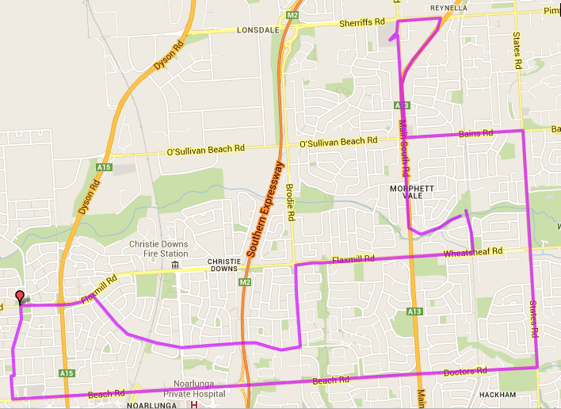

**Directions continued**

1. Cross States Road and turn left to the church
2. Follow States Road till shops just before Wheatsheaf Road roundabout
3. Continue along States Road until Bains Road and turn left – follow till Main South Road traffic lights
4. Cross MS road and turn right, following the road towards McDonalds (Sheriffs Rd)
5. Turn left into Sheriffs Rd to top of hill and Southgate shopping centre
6. Follow Hillier road down the hill, crossing Main South Road until Inner Wear (Old Church) on left
7. Continue until Traffic lights at Randell St
8. Continue down MS Road till the ‘On the Go’ petrol station
9. Turn left after the Emu hotel and follow the track back to the park

**Start & Finish**

**Discovery 1**